Instructions for viewing the status of expenses in Tick@lab:

1. Log on to aarhus.a-tune.com/tickatlab/default.aspx with your AU ID and associated password.

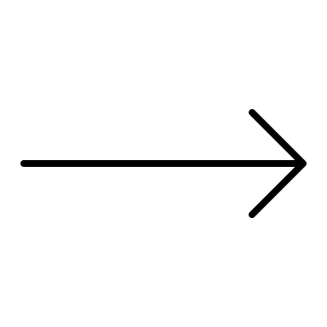
2. To see the status of your expenses for animals and housing, click on "Billing data" on the Billing tab.
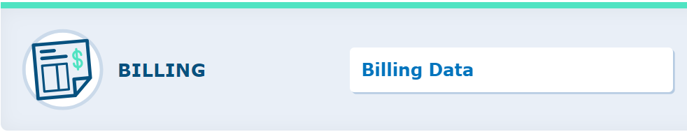

3. It is now possible to see both an overview and a detailed specification. The detailed specification is reviewed here. Therefore, click on the "Details" tab.
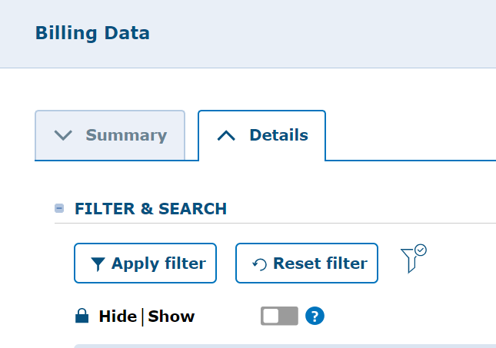

4. Now select the project account(s) you would like information on, and then click on "Apply Filter". The default setting only shows the current billing period, which is the current month. If you want to see a statement over an earlier or longer period, you must activate the "Hide/Show" button and mark the respective months in "Period:" and REMEMBER to remove the check mark in "Current Period:", which otherwise overrides your period election. Remember to finish with "Apply Filter" so that the list updates.
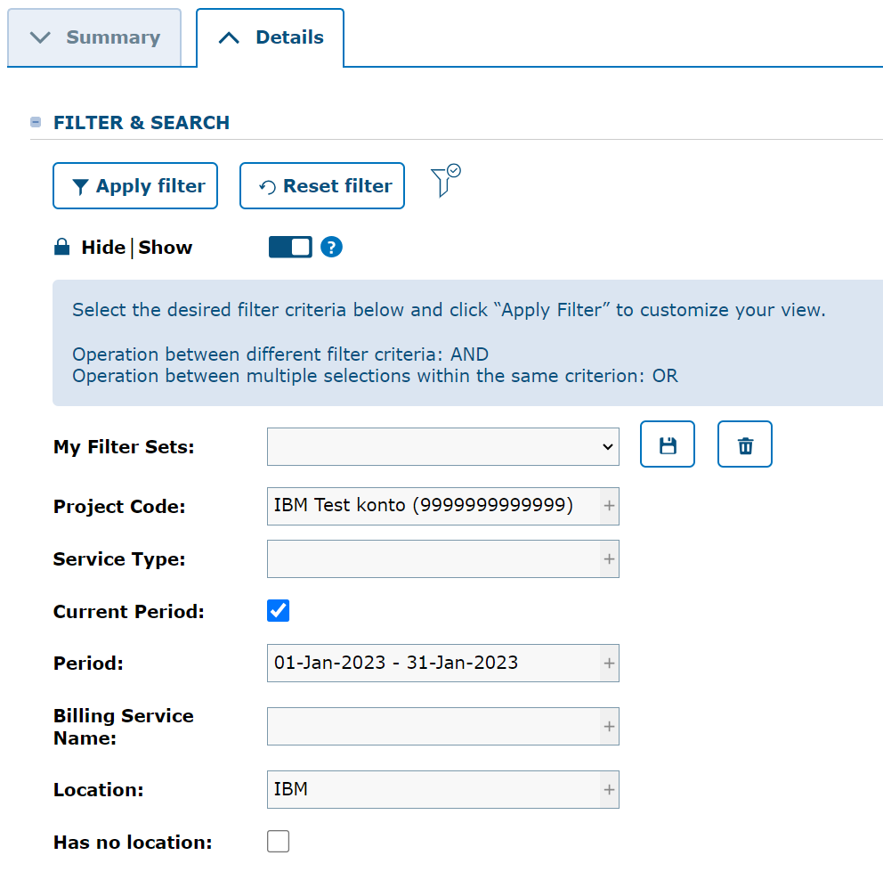
5. The system now creates a list with the expense items that have run on the project in question in the selected period.
It is possible to export data to Excel if you need to calculate the total expenses or something else.
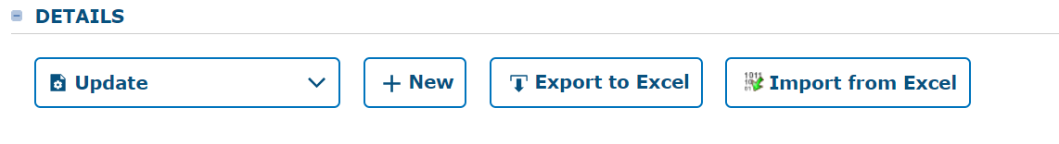
6. Remember that there can be different currencies for "Service Type" (DKK / Euro).

