Controls in Flow Cytometry

Written by: Anette Thomsen Date: May 2020

It is essential to make controls for your flow cytometry experiment.
Depending on the nature of your experiment, there are different controls to prepare:

- Instrument specific controls
  - Make sure the daily quality control has been run (QC or CS&T).
  - For longitudinal studies it is wise to run 8-peak beads (e.g. from Spherotech (1) or from Biolegend (2)) on each experiment day.
These beads should have the same MFI value (median fluorescence intensity) +/- 5% every day you run samples in the same experiment (gate for example on peak 6 in all the detectors you are using).

- Fluorescence controls
  - Autofluorescence control (unstained cells which have been treated exactly the same way as your stained cells (e.g. same number of washes, centrifugations and fixation).
  - Single stained compensation controls (3).

- Experimental controls

- Staining controls
  - Titrate your antibodies, make sure you are using the right amount of antibody. If the concentration is too high there is a risk of unspecific binding and in multi-colour panels, you will get higher data spread (4).
  - If you work with cells expressing Fc receptors, block the Fc receptor to avoid non- specific binding of reagents (5)
  - If you are using a two-layer antibody staining – it is important to include a control with the secondary antibody only.
  - Fluorescence minus one (FMO) controls (6). In the FMO control, all antibody conjugates in the experiment are included except the one that is controlled for. The FMO control provides a measure of the spread of fluorescence from the other staining parameters into the channel of interest, and may be useful to determine the threshold for positive staining.
This control can both be used for validating the compensation matrix (3).
  - Isotype controls. Be careful with these. They are not recommended as gating controls, but some reviewers still want them. However, be aware they should be used in the same antibody concentration and have the same fluorophore:protein ratio as your antibody which is difficult to control/be sure of unless you use large fluorochromes such as PE or APC. We are not recommending use of isotype controls.

  - Day to day controls are appropriate for longitudinal studies. Each day of analysis you stain a sample from a big batch of control cells the same way as you stain your test- samples. With a day-day control you can monitor assay performance and variability. If you forgot to add an antibody to your samples, it will be revealed.
The control samples can be MNC’s you have aliquoted and frozen or you can buy control cells.
  - If in doubt, whether your antibody binds specifically, an isoclonic control could be a good control. An isoclonic control is an antibody with the same specificity and clone as the conjugated antibody you are using, just un-conjugated – this un-conjugated version of your antibody should be able to outmatch the conjugated version.

- Biological controls

For transfected or transduced cells:
  - The best control to bring is mock transfected/transduced cells of the same type as your cells to be analyzed.
  - If possible, a clear positive control.
  - If you can’t provide a mock transfected/transduced cell line, negative cells will be accepted but is not optimal, since the autofluorescence of the cells often change during transfection/transduction.

For activated/stimulated cells:
  - Unstimulated cells, both unstained and fully stained cells.
  - Stimulated, but unstained cells
  - If possible, a positive control for stimulation

Data analysis controls
Initial steps in your data analysis should include the following:
  - Look at time in a dotplot to verify data have been acquired consistently (stable acquisition over time). In some software programs there are tools like FlowAI, FlowClean or FlowCut to automatically clean the data.
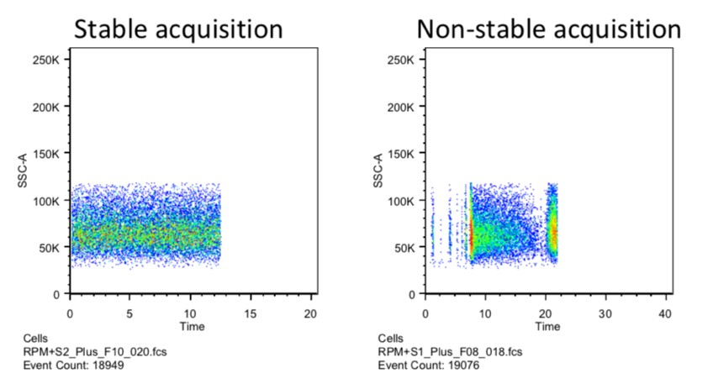

  - Remove doublets, to be sure you are looking at single cells – flow cytometry is a single cell technique. It has been shown that traditional doublet exclusion is not always enough, and you may need an extra marker to avoid immune complexes (7)
  - Remove dead cells. Dead cells have a tendency to bind antibodies un-specific.
  - Remove debris – or better gate on a positive marker (e.g. CD45 for leucocytes)

References:
- https://www.spherotech.com/CalibrationParticles.htm
- https://www.biolegend.com/en-us/products/rainbow-calibration-particles--8-peaks-3-0-3-4- m-8111
- FACS Core Facility Guidelines, Compensation in Flow Cytometry
- FACS Core Facility Guidelines, Titration in Flow Cytometry
- https://www.ncbi.nlm.nih.gov/pubmed/27731950
- https://currentprotocols.onlinelibrary.wiley.com/doi/full/10.1002/0471142956.cy0114s22
- https://www.ncbi.nlm.nih.gov/pubmed/31237234

