Spectral unmixing on ID7000
V. 1.3
Open ID7000 ID_{A} (analysis) software
Log in.
Go to Experiment → Reopen Experiment → Select the experiment you would like to open and chose Reopen in Acquisition (bottom of screen).
Select the sample group with data.

Choosing your autofluorescent universal negative gate:
- Mark your unstained sample → Unmixing → Autofluorescence Finder → OK
- Display Event → Choose an amount of events to be displayed (we recommend 50,000)
- Step 1: Place a gate around your cells of interest in the FSC-SSC plot.
- Step 2: Change the Y-axis to [VF-355] → Use the sliders below the plots to increase separation of populations → Highlight the plot you want to make a gate in → Place a tight gate around the most autofluorescent cells → OK → OK → Check “Calculate without saturated events”

Choosing positive signals from single stain controls:
- Choose a control → Adjust the positive gate in each of them
Make sure that you have a clean spectral pattern in your Positive ribbon plots.
If you create new gates instead of using the automatically added Positive gate, then right click the new gate → Assign Gate → Positive gate - Choose the correct parameter
- Unmixing → Unmixing Settings. Make sure positive and negative gates have been correctly assigned (you may use a universal negative, if single stains are only cells or only beads).
- Make sure you stand on the unstained sample. If you are using autofluoresence, make sure it is selected. Chose → Calculate → Check Calculate Spectral Reference without saturated event(s) → Continue → Apply

Review unmixed all stain sample:
- Mark your all stain sample → Place relevant gates to remove debris and doublets. You might also want to remove dead cells before you continue.
- Unmixing → Unmixing Viewer → Check On → Mark all your plots (you can use Shift) → Auto Adjust XY
- Skim your plots for banana shapes in the positive populations. If all looks good → Next
- Any plot(s) to the left of the perfectly diagonal plot have already been reviewed by you.
- If a plot contains “a banana shape”, turn the “ Adjuster” on. Drag the shape so the positive cells are on straight lines. Save the adjusted unmixing in a new name.
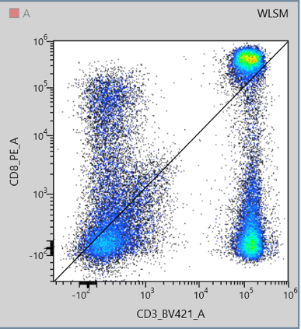
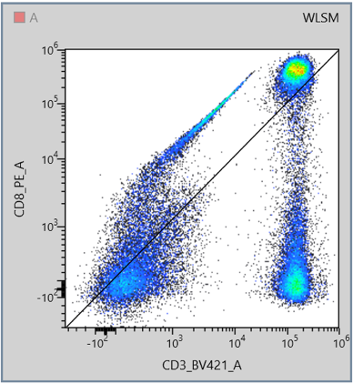
- Repeat step 10 until you have reviewed all fluorochromes, then Close.

Figure 1: "Banana-shape" to the left and correct unmixed populations to the right

Manually adjusting of unmixing:
- Unmixing → Spectral Reference Adjuster
- Start with the worst plot → Adjust the unmixing by dragging until the banana shapes are gone
Adjusting the worst plot can sometimes fix issues in other plots.
If you have many issues, your panel might need to be redesigned.
- When you are done, click OK → Name the unmixing matrix as you prefer → Save
- Verify your unmixing. Mark your all stain sample. Go to: Unmixing → Unmixing Viewer → Check On → Mark all your plots (you can use Shift) → Auto Adjust XY
- If your unmixing looks good, go to step 18. If you still have “banana shapes” repeat step 8-13.

Last steps:
- Acquisition → Close → You are automatically moved to Analysis → Right click your experiment → Chose the correct unmixing matrix→ Export to FCS file → Make sure the right path is chosen → Export → OK

